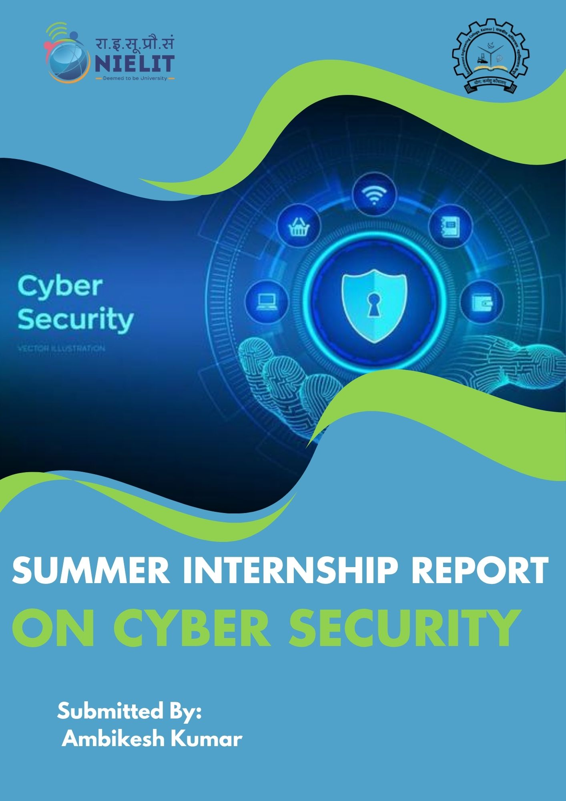

SUMMER INTERNSHIP REPORT ON CYBER SECURITY
Submitted by:
Ambikesh Kumar
Roll No.: 23-CSE(n)-03
Reg. No.: 23156148010
B.Tech (Computer Science & Engineering – Networks)
Government Engineering College, Kaimur

Submitted to:
The Head of Department,
Computer Science Engineering,
GEC Kaimur (Bihar)


Internship Institute:
National Institute of Electronics & Information Technology (NIELIT), Buxar

Internship Duration:
1 June 2025 – 30 June 2025
Submission Date:
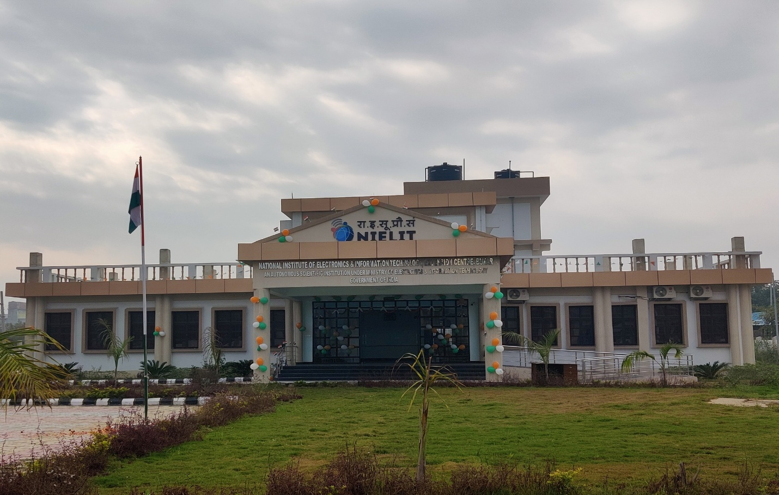

Group Details:
Group Name: Cyber Security Internship Group
Total Members: 9
Internship Program: Cyber Security Summer Internship
Internship Organization: NIELIT, Buxar
Internship Duration: 1 June 2025 – 30 June 2025
Group Members Information :
S. No. | Name : | Reg. Num.
1 | Ambikesh Kumar | 23156148010
2 | Asmit Raj | 23156148009
3 | Anand Chaubey | 23156148013
4 | Durgesh Kumar | 23156148024
5 | Sonam Kumari | 23152148005
6 | Mahima | 23152148020
7 | Neha Kumari | 23152148022
8 | Himanshu kumar | 23156148032
9 | Satendra kumar | 23156148015

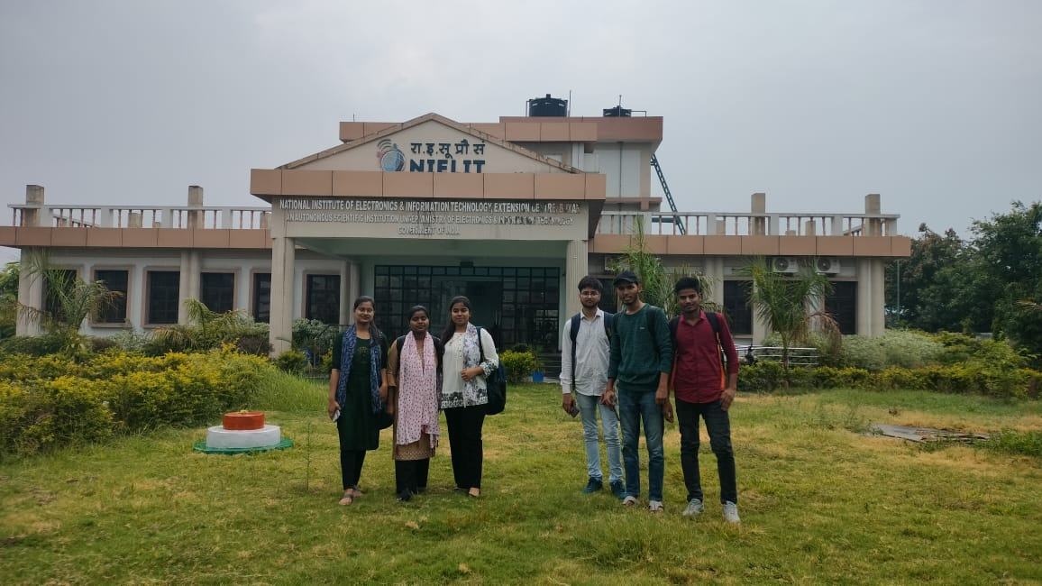
Group photo: -

Declaration:
I hereby declare that this Summer Internship Report titled “Cyber Security Internship Report” at NIELIT, Buxar, is a record of original work completed during June 2025. This report reflects the collaborative participation and shared learning of all nine group members listed in the report. However, as per the requirements of Government Engineering College, Kaimur, the report is being formally submitted by me, Ambikesh Kumar (Roll No.: 23-CSE(n)-03, Registration No.: 23156148010).
No part of this report has been copied or reproduced from any other source except where due reference has been made. The collective activities, contributions, and achievements of the group have been honestly represented.

Ambikesh Kumar
B.Tech (Computer Science & Engineering – Networks)
Government Engineering College, Kaimur (Bihar)
Date: 28 / 07/ 2025

Signature:

Certificate: 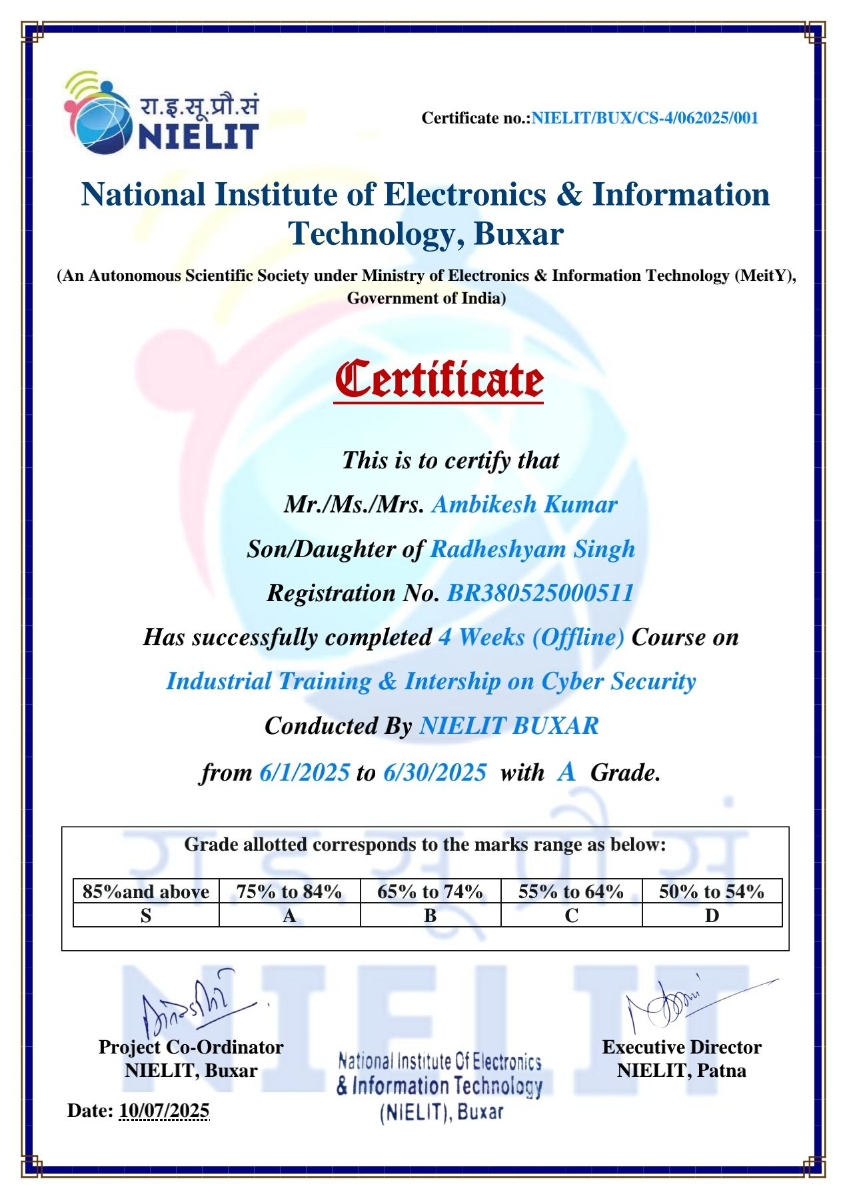

Acknowledgement
I would like to express my heartfelt gratitude to everyone who supported and guided me throughout my Cyber Security Summer Internship at NIELIT, Buxar.
First and foremost, I sincerely thank the entire faculty and staff of NIELIT, Buxar, especially our internship coordinators and trainers, for providing excellent training, valuable knowledge, and a practical learning environment during the internship.
I am also deeply grateful to my group members — Asmit Raj, Durgesh Kumar, Anand Chaubey, Mahima, Sonam Kumari, Neha Kumari, Himanshu Kumar, and Satyendra Kumar — for their cooperation, teamwork, and encouragement throughout this journey.
My sincere thanks go to the faculty and staff of Government Engineering College, Kaimur, for their constant support, guidance, and motivation.
Finally, I would like to thank my family and friends for their unwavering encouragement and understanding during this period.
This internship experience has been highly enriching and valuable because of the support and collaboration of all these individuals.

Ambikesh Kumar
B.Tech (Computer Science & Engineering – Networks)
Government Engineering College, Kaimur (Bihar)
Date: 28 / 07/ 2025

Table of Contents:
- Cover Page
- Declaration
- Certificate
- Acknowledgement
- Table of Contents
- Executive Summary
- Group Introduction
- Need & Objectives of the Internship
- Institute Profile (NIELIT, Buxar)
- Internship Syllabus / Structure
- Technical Learning & Practical Work
- Daily / Weekly Activities
- Professional & Soft Skills Learned
- Challenges & Solutions
- Analysis & Discussion
- Conclusion
- Recommendations
- References
- Appendices

Executive Summary:
This report presents a detailed account of the Cyber Security Summer Internship conducted at NIELIT, Buxar, by a group of nine students from Government Engineering College, Kaimur, during June 2025. The internship was strategically designed to provide both theoretical knowledge and practical skills necessary for understanding and combating contemporary cyber threats, a critical domain in the evolving field of information technology and network security.
Over the course of one month, our group underwent intensive training that covered fundamental principles of cyber security as well as advanced topics such as network architecture, firewall and antivirus implementation, phishing email analysis, penetration testing using tools like Kali Linux, incident response, data backup, and recovery strategies. The well-structured syllabus combined classroom teaching with hands-on lab sessions, enabling us to translate theory into practice effectively.
The group-based internship format encouraged collaboration and collective problem-solving. Each member actively participated in daily exercises, discussions, and projects that enhanced not only individual technical competencies but also essential soft skills such as communication, teamwork, time management, and presentation abilities. The opportunity to work in a cohort fostered a supportive learning environment where members shared insights, clarified doubts, and developed a comprehensive understanding of cyber security challenges.
Throughout the internship, our team faced multiple challenges, including mastering complex security tools, adapting to new software environments, and balancing time between various tasks. With consistent guidance from expert trainers at NIELIT and mutual support within the group, these challenges were transformed into valuable learning experiences that strengthened our analytical and practical skills.
The internship also provided exposure to real-world scenarios through case studies and simulated attacks, highlighting the importance of user awareness in preventing cyber attacks such as phishing and social engineering. We learned the criticality of comprehensive approaches combining technology, policy, and human factors to safeguard digital assets. The collaborative projects, especially in penetration testing and incident response drills enabled us to understand threat identification and mitigation processes in depth.
In addition to technical acumen, the internship enhanced our professional demeanor, emphasizing responsibility, ethical considerations, and effective documentation crucial for careers in cyber security. Regular presentations and report writing helped improve our ability to communicate complex ideas clearly and succinctly.
In conclusion, the Cyber Security Summer Internship at NIELIT, Buxar has been an enriching and transformative experience. It substantially deepened our knowledge of cyber security principles and practices while nurturing our confidence to tackle emerging threats. The blend of theoretical foundation, practical application, and teamwork has prepared us comprehensively for future academic pursuits and professional roles in this vital industry. We express our sincere gratitude to NIELIT, Buxar, our institute, faculty members, and peers for facilitating this learning journey. This internship has motivated us to further explore

advanced topics in cyber security and contribute meaningfully to strengthening digital infrastructure in our careers ahead.
Prepared by:
Ambikesh Kumar and Group Members
Cyber Security Summer Internship
NIELIT, Buxar
June 2025


Group Introduction:
Our Cyber Security Summer Internship was undertaken as a collaborative effort by a group of nine dedicated students from Government Engineering College, Kaimur. The group comprised Ambikesh Kumar, Asmit Raj, Durgesh Kumar, Anand Chaubey, Mahima, Sonam Kumari, Neha Kumari, Himanshu Kumar, and Satyendra Kumar—all pursuing the third semester of the Computer Science Engineering (Networks) branch.
The primary objective of forming this group was to combine our individual strengths and knowledge to effectively learn and apply cyber security concepts in a practical environment. Working together allowed us to share insights, divide tasks, and enhance our problem-solving capabilities during the intensive training sessions at NIELIT, Buxar.
Each member actively participated in various modules, including network security, penetration testing, incident response, and practical labs, fostering a spirit of teamwork and continuous learning. The group dynamic encouraged constructive discussions, mutual assistance, and collective achievement of the internship goals.
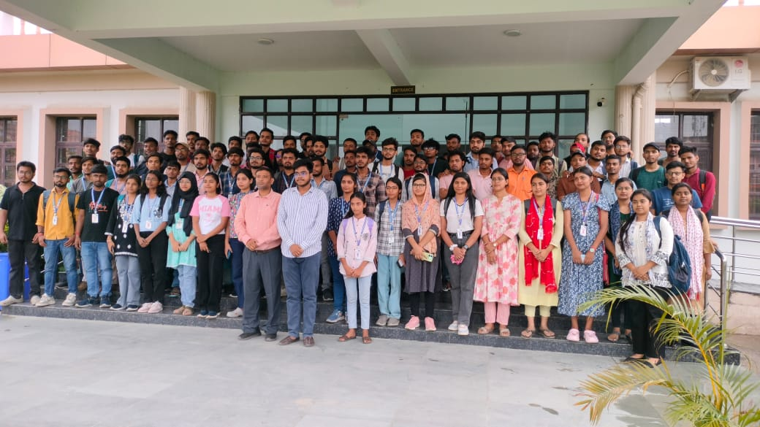
This collaborative approach not only enriched our technical understanding but also improved our communication, coordination, and professional skills—preparing us for future academic and industry challenges in the field of cyber security. The breadth of experience gained as a team has been invaluable, as each member contributed unique perspectives and efforts towards the successful completion of this internship

Need & Objectives of the Internship:
Need for the Internship
In the rapidly evolving technological landscape, cyber security has become a crucial aspect of protecting digital infrastructure, sensitive data, and organizational assets. With the proliferation of online services, the risks associated with cyber threats—such as hacking, phishing, malware attacks, and data breaches—have grown multifold. For aspiring computer science professionals, hands-on exposure to real-world security challenges is essential to bridge the gap between theoretical knowledge and industry practices.
The Cyber Security Summer Internship at NIELIT, Buxar, was designed to address this need by offering participants:
- Practical understanding of cyber security threats, tools, and defense mechanisms.
- Opportunity to work on live case studies and simulated cyber attacks in a secure lab environment.
- Guided training by domain experts to familiarize students with current industry trends and best practices.
- Exposure to crucial professional skills such as teamwork, communication, and problem-solving in the context of cyber security.
Objectives of the Internship
The primary objectives of undertaking this internship were:
- To gain in-depth knowledge of core cyber security concepts, including network security, threat analysis, firewall configuration, and incident response.
- To acquire hands-on experience with industry-standard tools and software such as Kali Linux, Wireshark, and various penetration testing frameworks.
- To understand the processes of identifying, preventing, and mitigating common cyber threats, including phishing, malware, and social engineering attacks.
- To enhance analytical thinking and problem-solving capabilities through participation in practical labs, project work, and group discussions.
- To develop collaborative skills and effective communication by working in a multi-member team, sharing responsibilities, and presenting findings.
- To bridge the gap between academic learning and industry requirements by engaging in real-time scenarios and expert interactions.
- To prepare for advanced professional roles and certifications in the field of information security, laying a strong foundation for future career opportunities.

Institute Profile:
National Institute of Electronics & Information Technology (NIELIT), Buxar
Overview
NIELIT, Buxar, is a prominent regional center of the National Institute of Electronics & Information Technology (NIELIT), operating under the Ministry of Electronics and Information Technology (MeitY), Government of India. Established to extend specialized IT, electronics, and digital skills training to the youth and professionals in Bihar, the center has become a key institution for capacity building in the region.
History
- Inception: NIELIT was set up with the mission to develop qualified human resources in the field of electronics and IT across India, with several regional centers. The Buxar center was opened to meet local demand for high-quality, industry-relevant training.
- Growth: Since establishment, NIELIT Buxar has progressed steadily, offering a variety of short-term and long-term courses and becoming a recognized hub for digital literacy and skill development in Bihar.
Mission and Vision
- Mission: To provide affordable, high-quality education, skill development, and certification in electronics, IT, and cyber security, bridging the gap between academia and industry.
- Vision: To empower the youth and professionals of India through state-of-the-art training, making them job-ready for the IT sector, and to support the nation’s digital transformation initiatives.
Branches and Network
- NIELIT is a national network with headquarters in New Delhi and dozens of regional centers across the country, including Patna and Buxar in Bihar.
- NIELIT Buxar works in close collaboration with other centers to offer standardized programs and certifications.
Major Programs and Courses
- Long-term programs: Diploma in Computer Applications, Advanced Diploma in IT and Electronics.
- Short-term certification courses:
  - Cyber Security
  - Digital Literacy
  - Programming Languages (Python, Java, C++)

  - Data Entry and Office Automation
- Workshops & Training:
  - Faculty Development Programs
  - Soft Skills & Employability Training
  - National level mega-events (seminars, hackathons, awareness camps)
- Special Focus Areas:
  - Summer Internship and Industrial Training for engineering students
  - Capacity Building for Government and Corporate Employees
  - Promoting Digital India and e-Governance awareness
Facilities
- Well-equipped computer labs with the latest technology
- Experienced and industry-certified trainers
- Digital classrooms and e-learning support
- Placement assistance for qualified candidates
NIELIT Buxar continues to play a vital role in spreading IT education and supporting the socio-economic growth of Bihar through modern, relevant, and hands-on programs tailored to industry requirements.
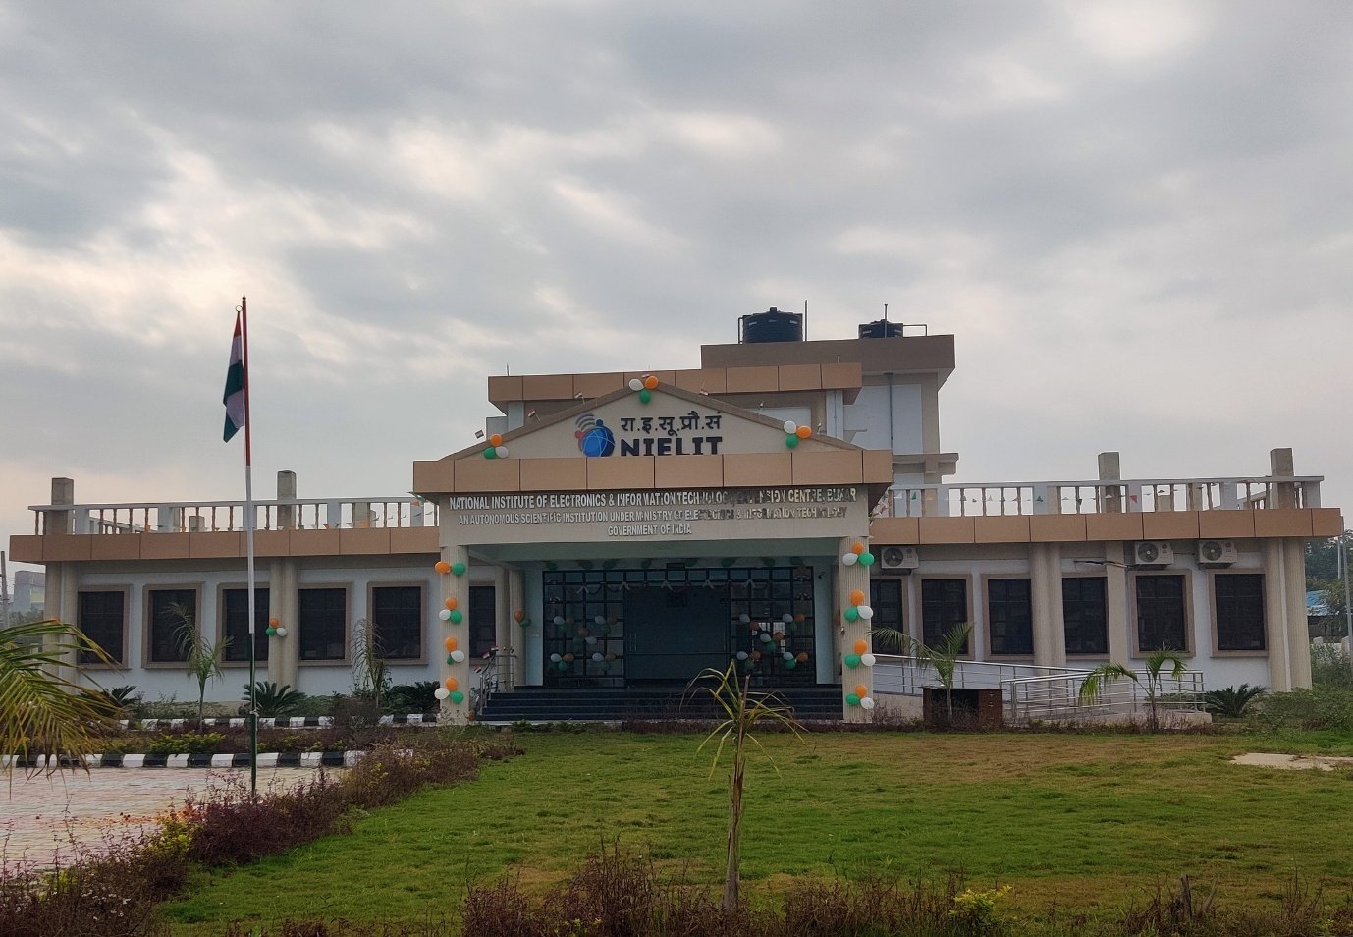

Internship Syllabus:
Week 1 (June 1 – June 7, 2025)
- Orientation and introduction to Cyber Security
- Understanding the importance and scope of Cyber Security
- Key concepts such as the CIA triad (Confidentiality, Integrity, Availability)
- Types of cyber threats and attacks overview
- Basic network fundamentals related to security (OSI, TCP/IP models)
- Introduction to malware types: viruses, worms, trojans
- Learning about social engineering and phishing techniques
- Overview of security tools like firewalls, antivirus, VPNs
- Basic encryption and authentication methods
Week 2 (June 8 – June 14, 2025)
- Deep dive into malware: ransomware and attack behaviors
- Case studies on malware and phishing attacks
- Social engineering tactics and their prevention
- Network security threats: DoS, DDoS, Man-in-the-Middle attacks
- Securing wireless networks and network monitoring
- Web application vulnerabilities (SQL injection, XSS, CSRF)
- Secure coding principles and Web Application Firewall (WAF) concepts
Week 3 (June 15 – June 21, 2025)
- Endpoint security: protecting devices like laptops, mobiles
- Patch management and vulnerability mitigation techniques
- Identity and Access Management (IAM), role-based access control
- Incident response process: preparation, detection, containment
- Disaster recovery and business continuity planning
- Introduction to cyber security frameworks (NIST, ISO 27001) and compliance
- Hands-on labs: penetration testing tools (Kali Linux), network traffic analysis (Wireshark)
Week 4 (June 22 – June 30, 2025)
- Cloud security fundamentals and challenges
- Ethical hacking and penetration testing practices
- Use of Kali Linux and other pen-testing tools for vulnerability assessment

- Emerging threats: AI-driven attacks, IoT vulnerabilities
- Future technology trends in cyber security (quantum computing, blockchain)
- Final project execution and group presentations
- Report preparation and feedback sessions
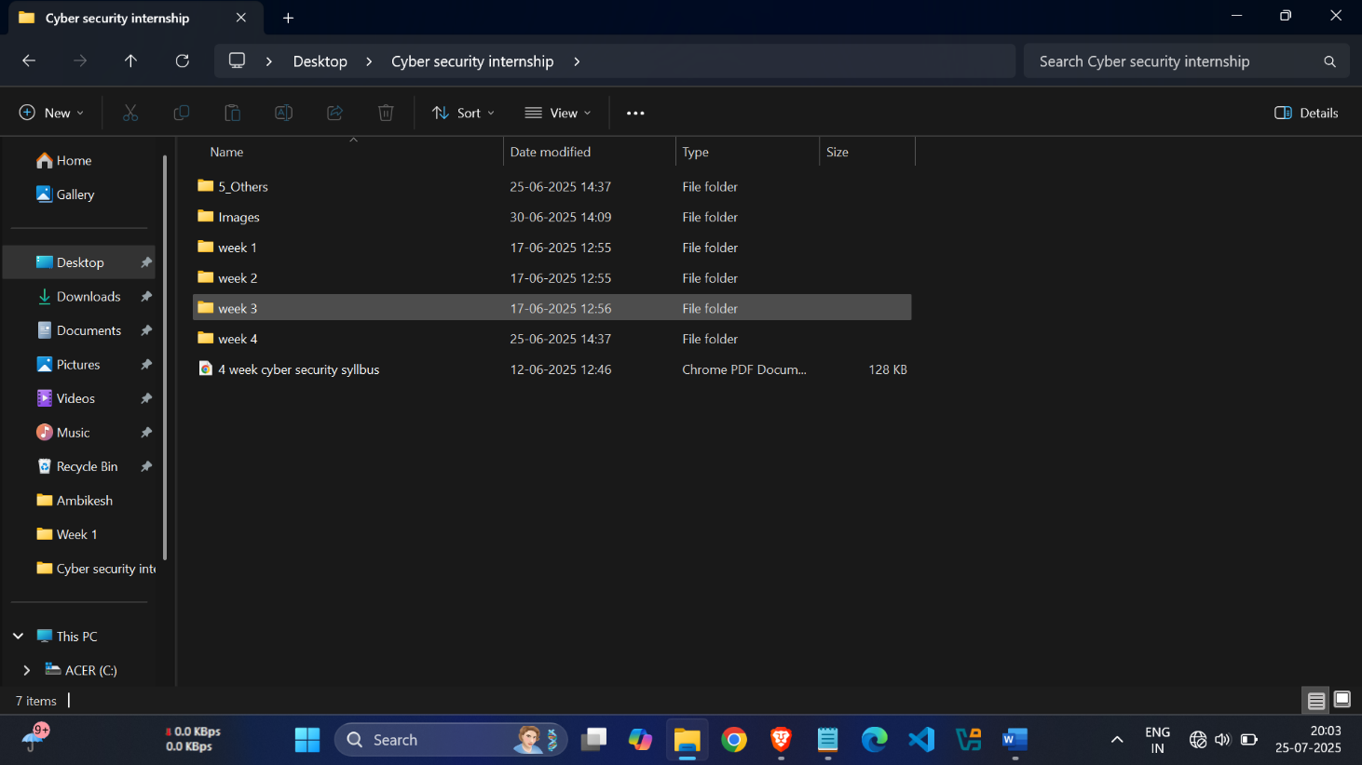
This week-wise structure covers both theoretical learning and practical application, aligned with your internship at NIELIT, Buxar. You can expand each point with your own experiences, tasks done, and insights gained during the internship.

Technical Learning & Practical Work:
During the Cyber Security Summer Internship at NIELIT, Buxar, our group gained substantial technical expertise through hands-on exposure to real-world scenarios, team projects, and instructor-led laboratory activities. Below are the main aspects of our technical learning and the practical work undertaken throughout the internship. Tools and Software Used
- Kali Linux:
Extensively used for penetration testing and ethical hacking exercises. It enabled students to perform vulnerability scans, exploitation of test systems, password cracking, and data packet analysis. The various pre-installed security tools within Kali Linux, such as Nmap, Metasploit, and John the Ripper, gave us practical insights into network and application-level vulnerabilities.
- Wireshark:
Employed as a packet analyzer for deep network traffic inspection. With Wireshark, we captured and analyzed live packets, understood protocols, detected suspicious activity, and learned how data traverses networks, helping in troubleshooting and forensic investigations.
- Firewall Tools:
Covered both hardware and software firewalls. We learned to configure, enable, and manage rules using inbuilt Windows Firewall, Linux iptables, and open-source firewall appliances such as pfSense. Activities included designing firewall rule sets, simulating attacks, and validating that only legitimate traffic was permitted.
Group and Individual Projects
- Network Vulnerability Assessment (Group):
As a group, we performed end-to-end vulnerability assessments of local lab networks using Kali Linux and Wireshark. Tasks included scanning network devices for open ports and security flaws, documenting all vulnerabilities, and recommending remediation steps. Each member practiced the roles of both attacker and defender in rotating simulations.
- Phishing Detection and Awareness Program (Individual):
Members created and analyzed simulated phishing emails to educate participants on recognizing social engineering attacks. Tools like Gophish (a phishing framework) and real email header analysis were employed. Each student prepared a micro-presentation on their findings and learning.

- Firewall Rules Implementation (Group):
The team collaboratively designed realistic scenarios where firewall rules were required to block malicious IPs, restrict unauthorized access, and log intrusion attempts. Tests were conducted by generating both legitimate and attack traffic to observe firewall responses.
- Incident Response Drill (Group):
The group participated in a simulated cyberattack and coordinated an incident response, following best practices to identify, contain, and recover from the breach. Each member took specific responsibilities—reporting, containment, forensics, or communication—to understand real-world response workflows.
Lab Activities:
- Hands-on Practical Sessions:
  - Setting up virtual lab environments for testing.
  - Installation and configuration of Kali Linux and Wireshark.
  - Simulating cyber-attacks such as port scanning, brute-force attempts, and phishing.
  - Monitoring network traffic during simulated attacks.
  - Evaluating antivirus efficacy and endpoint security in Windows and Linux systems.
  - Demonstrating the use of VPNs and secure tunnels for safe communication.
- Analysis and Documentation:
  - Preparing logs and reports for each activity.
  - Interpreting output from vulnerability scans.
  - Documenting firewall configuration and its effectiveness.
  - Group discussions on encountered challenges and solutions discovered.
Key Gains from Practical Work
- Proficiency in essential cyber security tools and understanding their role in threat detection and defense.
- Real-world experience of conducting network assessments and penetration tests.
- Ability to investigate cyber incidents, prepare reports, and communicate findings.
- Understanding of the critical role of teamwork, clear documentation, and effective communication in cyber security operations.

The technical learning and project-based practical work throughout the internship have laid a robust foundation for further academic study and professional development in the ever-evolving field of cyber security.
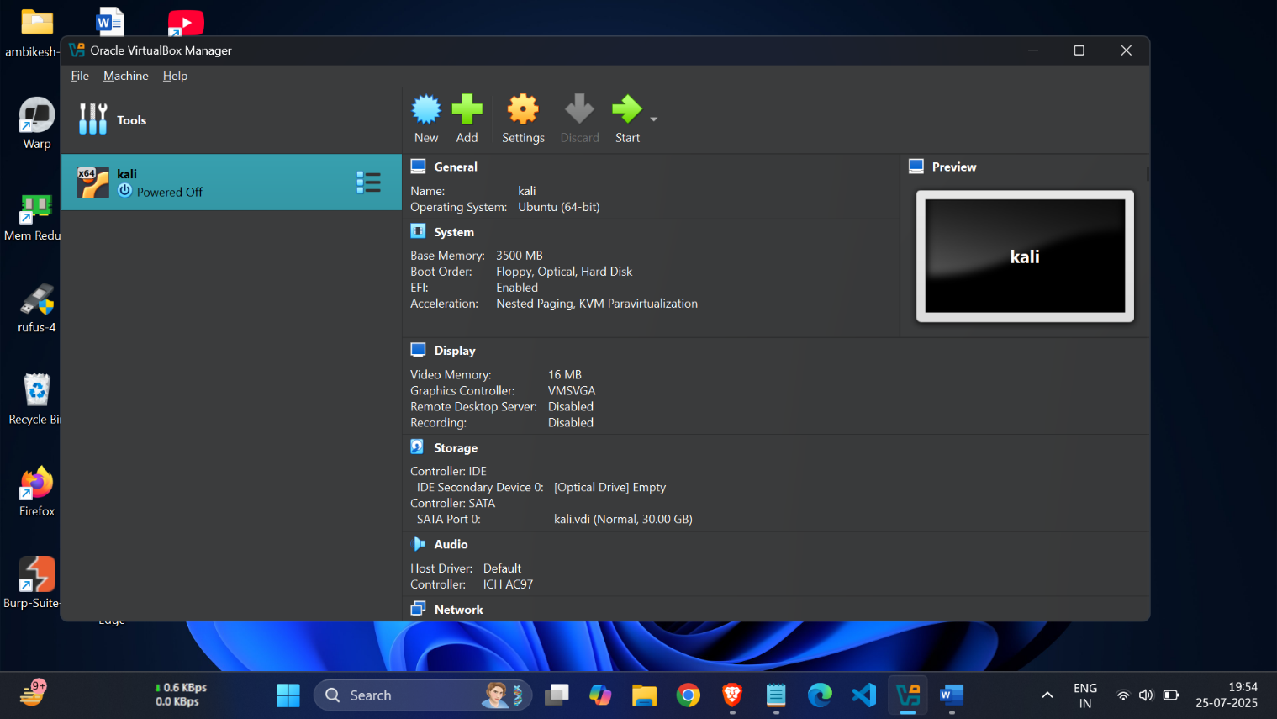

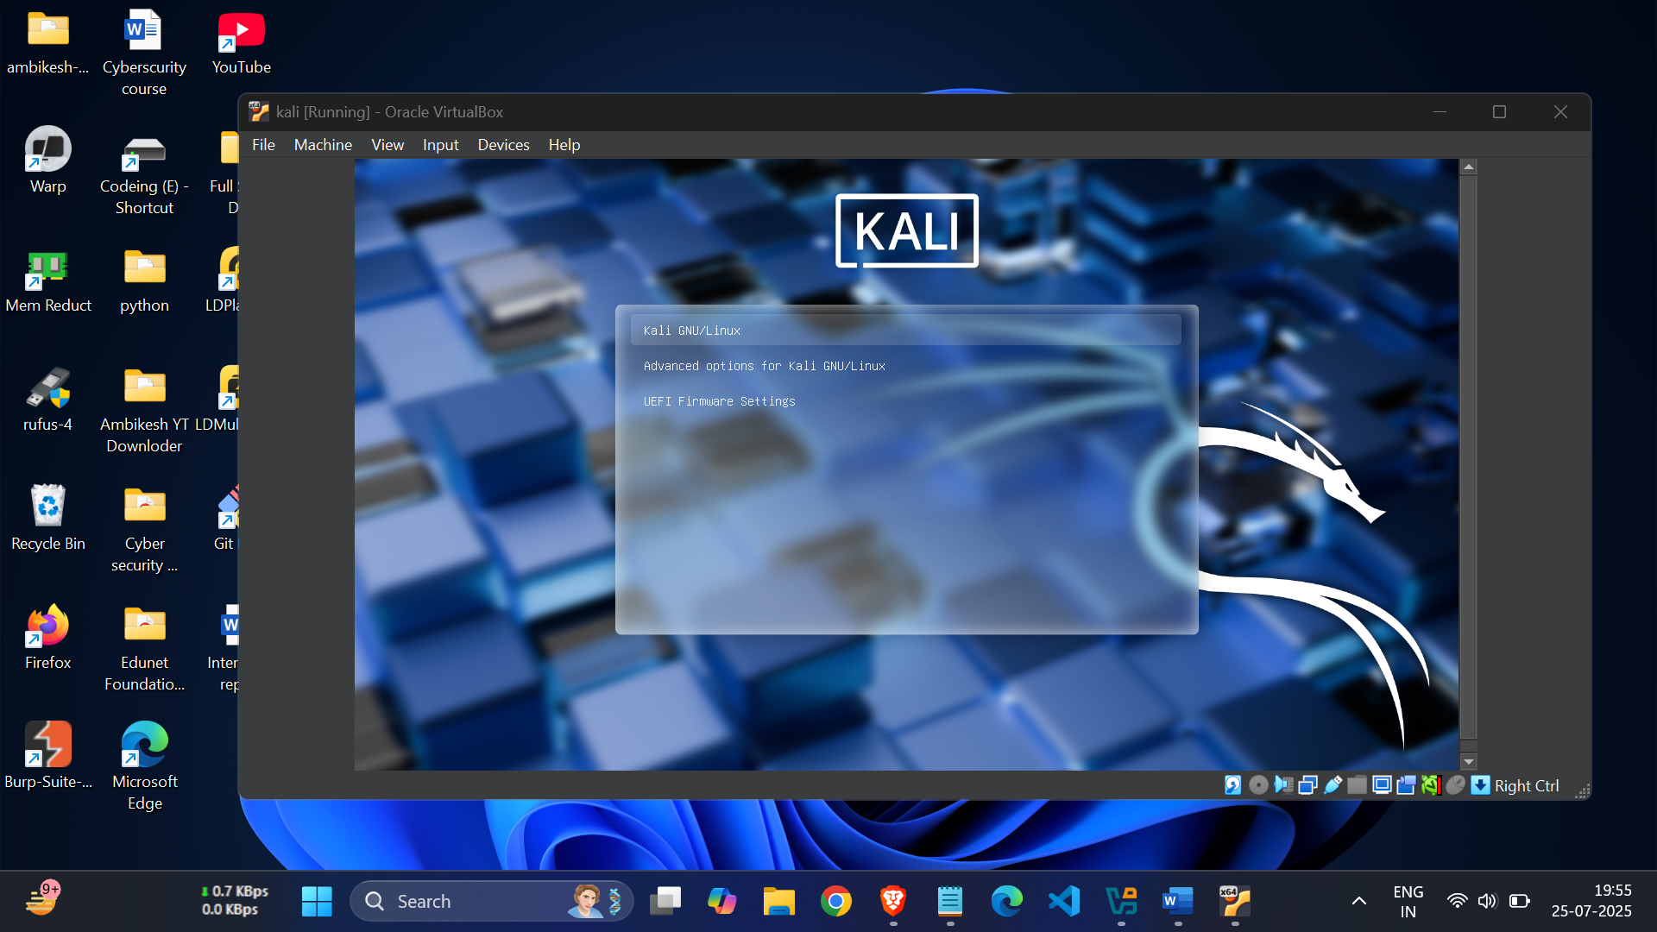

Daily/Weekly Activities (Summary):
- Week 1: Orientation, basics of Cyber Security and networking, introduction to malware, phishing, and security tools.
- Week 2: Malware and ransomware analysis, social engineering attacks, network threats (DoS/DDoS), web application security, and firewall basics.
- Week 3: Endpoint security, identity and access management, incident response drills, penetration testing using Kali Linux, and network traffic analysis with Wireshark.
- Week 4: Cloud security, advanced penetration testing, emerging threats, final group project, presentations, and report writing.
All group members actively participated throughout, sharing tasks, learning practical skills, and collaborating on projects and presentations.

Professional & Soft Skills Learned:
During the Cyber Security Summer Internship at NIELIT, Buxar, our group not only enhanced technical expertise but also developed essential professional and soft skills that are critical for success in the workplace and future careers. Key soft skills gained include:
- Communication Skills:
Through regular presentations, group discussions, and report writing, we learned how to articulate complex technical concepts clearly and effectively to both technical and non-technical audiences. This improved our verbal and written communication, enabling us to convey ideas, findings, and recommendations confidently.
- Teamwork and Collaboration:
Working as a group of nine members, we cultivated a strong spirit of cooperation and mutual support. We divided tasks, shared knowledge, and coordinated effectively to complete projects and solve problems. This collaborative environment enhanced our ability to work cohesively in diverse teams, a vital skill in professional settings.
- Time Management:
Balancing multiple training modules, lab sessions, and project deadlines required careful planning and prioritization. We developed skills in organizing our schedules, allocating time efficiently, and meeting deadlines without compromising the quality of work.
- Problem-Solving and Critical Thinking:
Encountering real-world cyber security challenges during labs and projects encouraged us to think critically and systematically approach problems. We learned to analyze issues, evaluate options, and implement solutions effectively, which sharpened our decision-making abilities.
- Presentation Skills:
Delivering group presentations on project outcomes, case studies, and technical topics helped us gain confidence in public speaking and using visual aids effectively. These sessions honed our ability to engage an audience and communicate findings in a structured manner.
- Professionalism and Ethical Awareness:
The internship emphasized the importance of ethics in cyber security, responsibility in handling sensitive data, and maintaining confidentiality. We
- recognized the need for integrity and professionalism in all tasks and interactions.
Overall, these professional and soft skills complement the technical knowledge gained and prepare us to thrive in collaborative, fast-paced, and dynamic environments in the cyber security and IT industries.

Analysis & Discussion:
The Cyber Security Summer Internship at NIELIT, Buxar, provided an immersive experience that bridged theoretical concepts with practical exposure. Our group engaged in a variety of laboratory exercises, real-world case studies, and collaborative sessions, each of which contributed to a holistic understanding of cyber security in action.
Insights from Lab Experiences
- Hands-on Tool Usage:
Working directly with industry-standard tools like Kali Linux and Wireshark offered practical understanding of penetration testing, network monitoring, and traffic analysis. Setting up firewalls, performing vulnerability assessments, and simulating attacks made the defense mechanisms tangible rather than abstract.
- Simulated Attack & Defense Scenarios:
Through simulated cyber attacks—such as phishing, brute-force login attempts, and malware infections—we observed both the effectiveness and limitations of various security controls. This experience demonstrated that proactive detection and layered security are crucial for robust defense.
- Incident Response Drills:
Participating in incident response simulations fostered a deeper appreciation for structured response procedures, teamwork under pressure, and the importance of accurate documentation in real-world breach scenarios. Live Case Studies
- Real-World Problem Solving:
Study of recent cyber incidents (e.g., ransomware attacks, data breaches) was integrated into lab work. We examined how theoretical protocols—like those in NIST and ISO standards—are actually implemented (or overlooked) in real organizations, and what consequences result from gaps in security.
- Application of Theory:
Analysis of phishing emails, network intrusion cases, and endpoint infections enabled us to apply concepts such as CIA triad, authentication mechanisms, and access control policies to current events. These exercises boosted our understanding of how cyber security incidents unfold and are resolved in practice.

Learnings from Group Discussions:
- Diverse Perspectives:
Regular group discussions sparked a range of ideas on securing information systems. Each member contributed unique approaches to solving problems, which highlighted the importance of collaboration in cyber defense.
- Knowledge Sharing:
Peer-to-peer teaching—where one student explained findings or tool usage to others—reinforced collective learning and filled knowledge gaps across the group.
- Critical Thinking:
Debating case study outcomes and reflecting on lab results encouraged analytic thinking, helping us move beyond “what” to “why” and “how” security threats should be addressed.
Theory-Practice Integration
- Alignment of Theory with Practical Tasks:
Core theoretical principles—such as network segmentation, secure coding, least privilege, and multi-factor authentication—were directly applied in labs, making their necessity clear and their implementation memorable.
- Observed Gaps and Realizations:
While theoretical frameworks provide a blueprint, practical implementation revealed areas where standard solutions may fall short without careful adaptation. For instance, firewall configurations required iterative adjustments based on live traffic, much more nuanced than static textbook rules suggest.
- Professional Skills:
Preparing presentations, project documentation, and incident reports underscored the link between technical competence and professional communication, a crucial aspect often underemphasized in academic settings.

Conclusion:
The Cyber Security Summer Internship at NIELIT, Buxar provided our group with a comprehensive learning experience that significantly enhanced both our technical knowledge and professional skills. Throughout this internship, we gained a deeper understanding of core cyber security principles such as network security, threat identification and mitigation, penetration testing, incident response, and the use of vital tools like Kali Linux and Wireshark. The hands-on practical sessions bridged the gap between theory and real-world application, solidifying concepts through immersive lab work and simulated attacks.
Beyond technical expertise, the internship fostered personal growth by emphasizing the importance of effective communication, teamwork, and time management. Working collaboratively as a group of nine enabled us to share diverse perspectives, distribute tasks efficiently, and support each other in overcoming challenges. This collective effort strengthened our problem-solving abilities and nurtured a collaborative spirit essential for success in the dynamic field of cyber security.
The exposure to live case studies, incident response drills, and project presentations prepared us not only to understand contemporary cyber threats but also to anticipate and adapt to emerging vulnerabilities. The combined theoretical foundations and practical experiences have equipped us with confidence and readiness to face future challenges in cyber security, whether in academic pursuits or professional environments.
In summary, this internship was a valuable stepping stone that enhanced our knowledge, skills, and teamwork capabilities. It has motivated us to continue learning and contributed significantly to our preparation for advancing in the ever-evolving domain of information security.

Prepared by:
Ambikesh Kumar and Group Members
Cyber Security Summer Internship
NIELIT, Buxar
July 2025

Recommendations:
Based on our group’s learning experience during the Cyber Security Summer Internship at NIELIT, Buxar, the following recommendations are proposed to enhance the effectiveness of future internships—for the institute, trainers, and upcoming batches of students:
1. Increase Hands-on Live Projects
- Incorporate more real-world, scenario-driven live projects alongside lab exercises so that students can work on current security challenges faced by organizations.
- Include collaborative capstone projects that require teams to perform complete security audits, from vulnerability assessment to mitigation reporting.
2. Enhance Group Work and Collaboration
- Encourage diverse group tasks that rotate leadership roles among members, enabling everyone to develop coordination, leadership, and communication abilities.
- Organize peer code reviews and security walkthrough sessions where groups can analyze and critique one another’s work for constructive learning.
3. Expand Industry Interaction and Guest Sessions
- Invite industry guest speakers or professionals from leading IT security companies to share case studies and practical perspectives on current threats and solutions.
- Arrange virtual or physical visits to cyber security operation centers (CSOCs) or data centers for on-ground exposure.
4. Focus on Advanced and Emerging Topics
- Integrate advanced modules on cloud security, AI-driven cyber threats, IoT vulnerabilities, and blockchain applications in cyber security to align with industry evolution.
- Include simulated attack-defense competitions (such as Capture the Flag events), boosting real-time problem-solving skills.
5. Continuous Evaluation and Feedback
- Implement periodic quizzes, mini-tests, and feedback sessions after each module to track progress and ensure conceptual clarity.
- Provide structured feedback to students on their performance in group projects and presentations to guide further improvement.
6. Resource and Facilities Enhancement
- Upgrade lab infrastructure with the latest security appliances, updated software tools, and ample workstations to support simultaneous group activities.
- Give each student access to a cloud-based cyber range for remote practice beyond standard lab hours.
7. Support for Certification and Further Learning

- Offer guidance and preparatory resources for international cyber security certifications (such as CEH, CompTIA Security+, CISSP) to help students build recognized credentials.
- Maintain a digital repository of class notes, recorded sessions, and project documentation for continuous reference.
8. Greater Emphasis on Professional Skills
- Conduct dedicated workshops focused on report writing, project documentation, incident communication, and security ethics.
- Simulate real-world business scenarios where students must present their findings to non-technical stakeholders for enhanced communication practice.
For future batches:
Take initiative in group coordination, seek clarification proactively, and fully engage in all sessions—both technical and soft skills oriented. Embrace teamwork, respect deadlines, and make the most of networking opportunities with peers and mentors.
For the institute:
Periodically update the curriculum in line with global best practices and industry requirements, fostering a robust and adaptive learning environment for every cohort of cyber security interns.
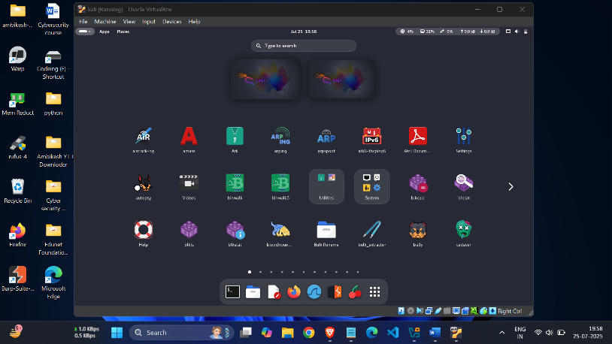
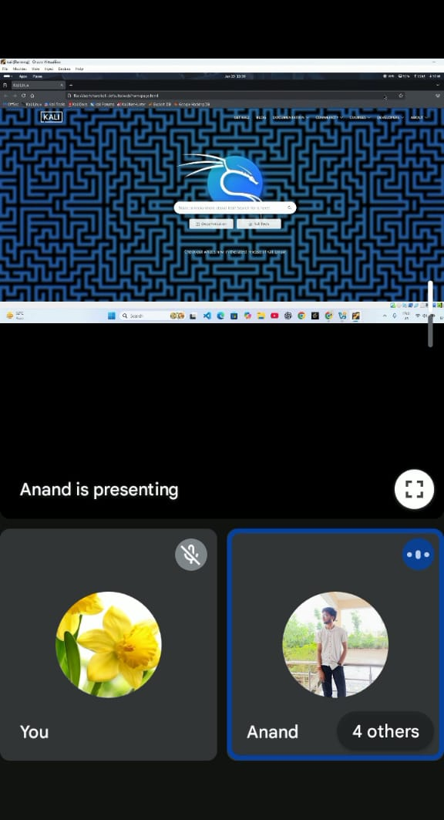
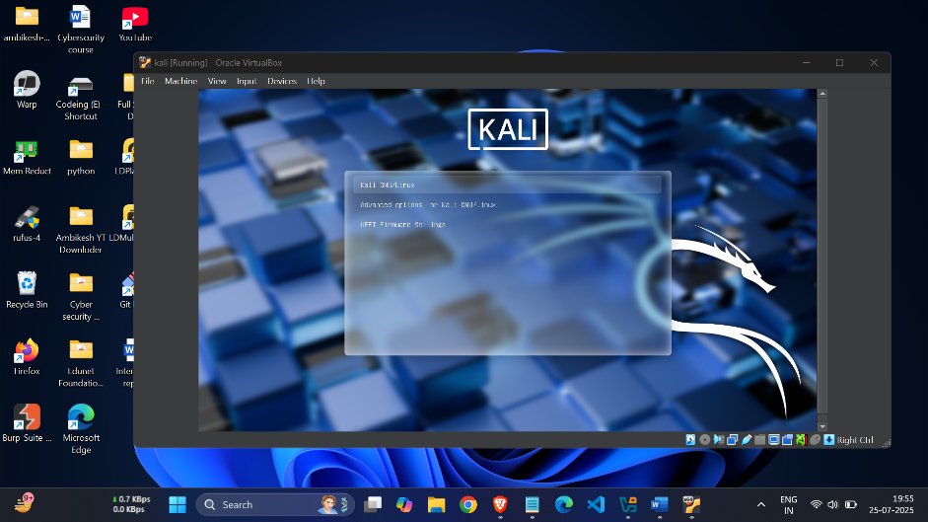

Appendices:
This section includes all the supplementary documents and supporting materials related to our Cyber Security Summer Internship at NIELIT, Buxar. These appendices provide evidence of our successful completion, practical work, group activities, and key moments during the internship.
A. Certificates of Internship Completion
- Scanned copies or photographs of the internship completion certificates awarded to all nine group members by NIELIT, Buxar.
- These certificates validate our participation and successful fulfillment of all training modules and practical requirements.
B. Sample Project Reports and Codes
- Excerpts and summaries of the group project reports prepared during the internship, including:
  - Network vulnerability assessments
  - Penetration testing documentation
  - Phishing awareness analysis
- Sample code snippets or configurations used during penetration testing and firewall rule implementation (if applicable).
- Reports highlighting the methodology, observations, and conclusions drawn from our practical assignments.
C. Group Photographs
- Photographs featuring all group members taken during various stages of the internship, such as:
  - Orientation day group photo at NIELIT, Buxar campus
  - Team working on lab activities and discussions
  - Presentation and project review sessions
- These photos capture the collaborative spirit and environment of the internship.
D. Laboratory Photographs
- Images showing hands-on sessions including usage of Kali Linux, Wireshark, firewall configuration labs, and incident response drills.
- Photos of computer setups, lab infrastructure, and practical demonstrations.
- Capture of interactions with trainers or mentors during live exercises.
E. Additional Supporting Documents (Optional)
- Daily or weekly attendance sheets (if maintained).
- Training module handouts or syllabus excerpts provided by NIELIT.
- Supervisor’s evaluation or feedback forms.

- Any other relevant certificates, letters, or appreciations received during the internship.
Note: All documents and images included in the Appendices are arranged sequentially and properly labeled with captions (e.g., “Appendix A: Internship Completion Certificate – Ambikesh Kumar”). These materials substantiate the efforts, learning, and achievements of our group throughout the internship period.
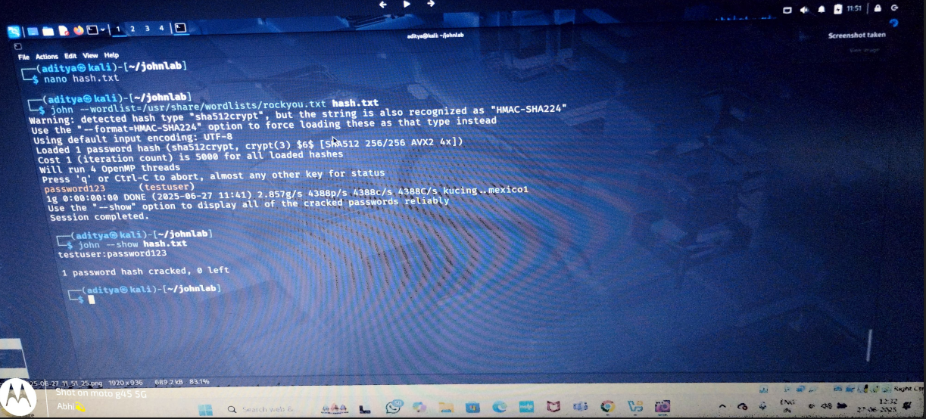
If you want, I can help prepare an organized format for these appendices with example captions and layout suggestions.


